**Christmas in the United Kingdom https://www.whychristmas.com/i/hollyr.png  
**

In the UK (or Great Britain), families often celebrate Christmas together, so they can watch each other open their presents!

Most families have a [Christmas Tree](https://www.whychristmas.com/customs/trees.shtml) (or maybe even two!) in their house for Christmas. The decorating of the tree is usually a family occasion, with everyone helping. Christmas Trees were first popularized the UK by Prince Albert, the husband of Queen Victoria. Prince Albert was [German](https://www.whychristmas.com/cultures/germany.shtml), and thought that it would be good to use one of his ways of celebrating Christmas in to England.

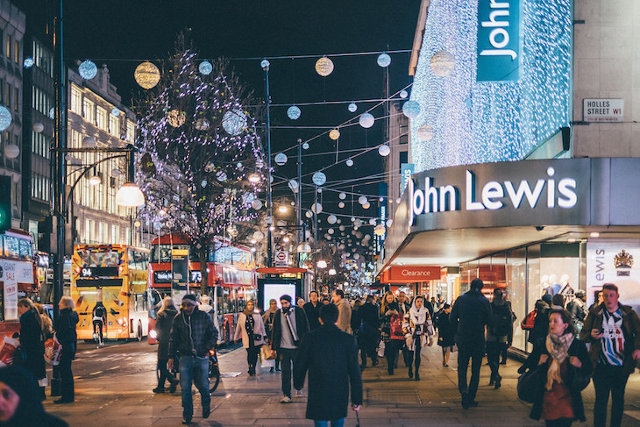[Holly, Ivy](https://www.whychristmas.com/customs/hollyandivy.shtml) and [Mistletoe](https://www.whychristmas.com/customs/mistletoe.shtml) are also sometimes used to decorate homes or other buildings.

Most villages, towns and cities are decorated with Christmas lights over Christmas. Often a famous person switches them on. The most famous Christmas lights in the UK are in Oxford Street in London. Every year they get bigger and better. Thousands of people go to watch the big 'switch on' around the beginning of November.

Children believe that [Father Christmas or Santa Claus](https://www.whychristmas.com/customs/fatherchristmas.shtml) leaves [presents](https://www.whychristmas.com/customs/presents.shtml) in stockings or pillow-cases. These are normally hung up by the fire or by the children's beds on Christmas Eve. Children sometimes leave out [mince pies](https://www.whychristmas.com/customs/mincepies.shtml) and brandy for Father Christmas to eat and drink when he visits them. Now, some people say that a non-alcoholic drink should be left for Santa as he must drive!

Children write letters to Father Christmas/Santa listing their requests, but sometimes instead of putting them in the post, the letters are tossed into the fireplace. The draught carries the letters up the chimney and Father Christmas/Santa reads the smoke.

There are some customs that only take place, or were started, in the UK. [Boxing Day](https://www.whychristmas.com/customs/boxingday.shtml) is a very old custom that started in the UK and is now taken as a holiday in many countries around the world.

In the UK, the main Christmas Meal is usually eaten at lunchtime or early afternoon on Christmas Day. It's normally roast turkey, roast vegetables and 'all the trimmings' which means vegetables like carrots & peas, stuffing and sometimes bacon and sausages. It's often served with cranberry sauce and bread sauce. Traditionally, and before turkey was available, roast beef or goose was the main Christmas meal. One vegetable that is often at Christmas in the UK are brussel sprouts. I love them but lots of people don't!

Dessert is often [Christmas Pudding](https://www.whychristmas.com/customs/pudding.shtml). Mince pies and lots of chocolates are often eaten as well!

Trifle is also a popular dessert at Christmas. It's made in a large bowl and consists of a layer of sponge cake (or sponge fingers) at the bottom of the bowl (which is often soaked in sherry or brandy) then there's a layer of fruit (normally suspended in a fruit flavored jelly) and it's topped with a layer of custard and then whipped cream. In Scotland there's a variation called 'Tipsy Laird' which uses whiskey to soak the sponge and the fruit are raspberries.

The dinner table is decorated with a [Christmas Cracker](https://www.whychristmas.com/customs/crackers.shtml) for each person and sometimes flowers and candles.

The UK is also famous for [Christmas Cake](https://www.whychristmas.com/fun/recipe_christmas_cake.shtml) - some people love it and some people really don't like it! It's traditionally a rich fruit cake covered with marzipan and icing - and often top with Christmas themed cake decorations like a spring of holly.